## Chapter 4.6 Algorithm based on Index

***Instruction:***

Several kinds of Algorithm need Index on one or more fields in Relation. Selection Operation based on Index is especially useful, but for Join Algorithm and other Binary Operator Algorithm also have some benefits. In this chapter, we will introduce the algorithm.

### Chapter 4.6.1 Cluster and Non - Cluster Index

***Definition:***

1. Cluster - If the number of tuple in one Relation can be contracted to store as little as possible, then this Relation is Cluster. All analysis so far are all based on cluster.
2. Cluster Index on one or more attributes, then all tuples with the fixed value can be put into little blocks.

***Attention:***

Non - cluster Relation can not have one cluster index, but one Cluster Relation can have non - cluster index.

***Example:***

* Relation R(a, b), sorted by property a and stored based on this sequence, then if Relation R(a, b) stores into the block, it must be cluster. For one given property *a* - with value *a1*, all tuples with value *a1* are stored sequentially, so the index on property *a* is cluster index.
* See the picture below, except the first and the last block which contain the value *a1*, they are all stored on the block. But actually, index on the property *b* may not be cluster, since there has one tuple with the fixed value *b* can be divided into the file, except that there has close relationship with property *a* and *b*.

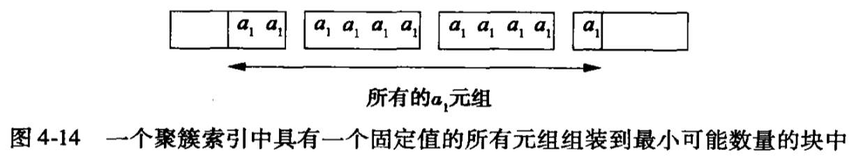

### Chapter 4.6.2 Selection based on Index

***Principle:***

Think about when tuples that satisfy the condition C which equals to a = v, here a is one property with the value of v. Here using the value v to search index and get those tuples that satisfy the conditions, after that we just get them back.

***Situation 1 - Cluster:***

If the index on Relation R.a is Cluster, then the number of disk I/O that getting back collection which satisfies condition *a = v* equals nearly to *B(R) / V(R, a)*, but actually the number may be higher, because:

1. The index may not be all stored into main memory, it needs some disk I/O to support Query on index.
2. Even all tuples with the condition *a = v* can be stored into the b blocks, it may be divided into b + 1 blocks, since they may not start from one block.
3. Although tuples of Relation R is cluster, they may not be fully stored into blocks.
4. If *B(R) / V(R, a)* is not a integer, then we need to round up to an integer. If property a is one key of Relation R, then *V(R, a) = T(R)*, then we can suppose it must be bigger than *B(R)*. Then we need one disk I/O and another disk I/O to access the index.

***Situation 2 - Non - Cluster:***

Think about when the index on R.a is non - cluster, then what happens next. If each tuple we get back is on different blocks, and we must access T(R) / V(R, a) tuples. Therefore T(R) / V(R, a) is the estimated disk I/O times. Although the number may be higher, since we need to read some index blocks from disk; Also it may be lower, since these tuples may be appear in one block and this block exists in the main memory.

***Example:***

B(R) = 1000, T(R) = 20000, then there has 20000 tuples which has been put into 20 blocks, assume that a is one property of Relation R and there has an index on the property a. Then for Selection Operation when a = 0.

Below are possible situations and the numbers of disk I/O under the worst situation:

1. Relation R is cluster, but we do not use index, then the cost will be 1000 times disk I/O.
2. If Relation R is not cluster and we can not use index, then the cost will be 2000 times disk I/O. So we must retrieve each block of Relation R.
3. If V(R, a) = 100 and the index is cluster, then the algorithm based on index needs 1000 / 100 = 10 disk I/O, add the cost to access the index.
4. If V(R, a) = 100 and the index is non - cluster, then the algorithm based on index needs 20000 / 100 = 2000 times disk I/O.
5. If V(R, a) = 20000, which is to say that property a is a key, then considering the Algorithm based on the index, no matter the index is cluster or non - cluster, then we needs one disk I/O and the disk I/O to access the index.

***Addition:***

1. One index, such as B tree, can make us access the Query Key within the given range. If there has one index on property a on the Relation R, then we can use index to retrieve all needed tuples of Relation R within the condition of a >= 10, a <= 10 and a <= 20.
2. For one more complex Selection Operation with much more complex condition C, then using method below to realize: after scanning all index and getting tuples, then operate another Selection Operation on the result tuples.

### Chapter 4.6.3 Connection by Using Index

### Chapter 4.6.4 Join by Using Ordered Index